**Openshift**

* Openshift is an extension to k8s cluster (Kubernetes++)
* Openshift used k8s as container management platform & add several capabilities
  + Self-Service portal
  + Service Catalog
  + Build & application deployment
  + Built-in registry
  + Extended application routing
* Openshift Flavours
  + Openshift Origin
  + Openshift Container Platform
  + Openshift Online
  + Openshift dedicated
* Openshift Architecture 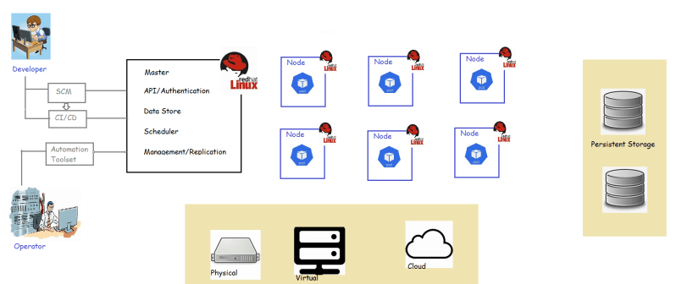

Openshift Components

* + Openshift masters
  + Openshift nodes
  + etcd as a key value store
  + Router as ingress traffic control
  + Openshift interna registry

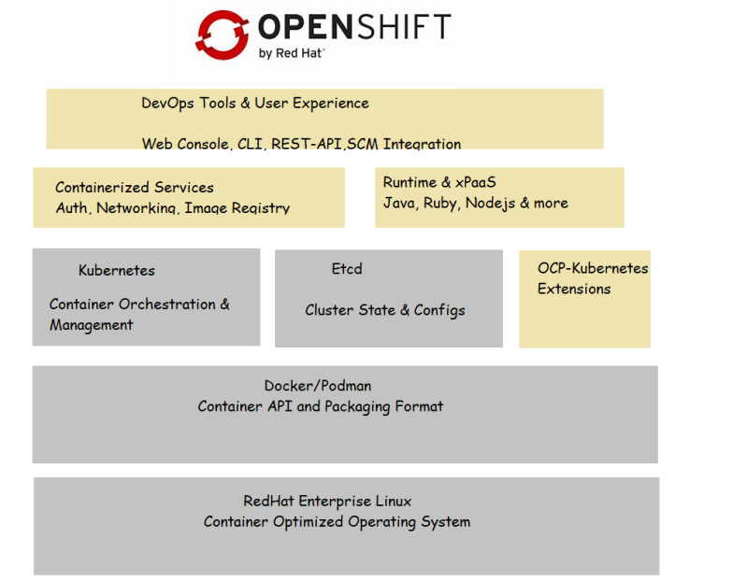

* Openshift developer env can be installed on machines using minishift(<https://www.okd.io/minishift/>)
* Let’s create an Openshift developer sandbox at Openshift online(https://www.okd.io/minishift/)

